## Priors for CMSY, CMSY-BSM and SPICT

# r

### SPICT

A prior can be set. A value with SD. Previously I’ve taken this from Fishbase

### CMSY

Defined at the outset. Set at High (0.6-1.5), Medium (0.2-0.8), Low (0.05-0.5) or Very Low (0.015-0.1). You can set the r range to be any range you chose though.

### BSM

r prior is set as the mean of the r range defined above. The s.d:



I’m not certain about this!

# k

### SPICT

A prior for k can be defined.

### CMSY

Different rules depending on the starting biomass of the stock. For stock with low biomass:



For stocks with high biomass:

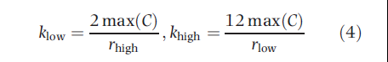

Froese et al paper, does not say what is used for stocks with medium biomass.

### BSM

Mean of k range was used as prior, and the sd?



## Initial Prior Biomass Range

### SPICT

Not that I can see.

### CMSY

Can be defined with a range, High (0.5-0.9), Medium (0.2-0.6) and Low (0.01-0.4). If not defined then the default rules are that if the time series starts before 1960, the stock is assumed to have high initial biomass!!!!!! In all other cases, medium initial biomass is assumed!

### BSM

???

## Final Biomass Prior Range

### SPICT

Not that I can see.

### CMSY

Can be manually defined similarly to initial prior range. If not then the default rules are:

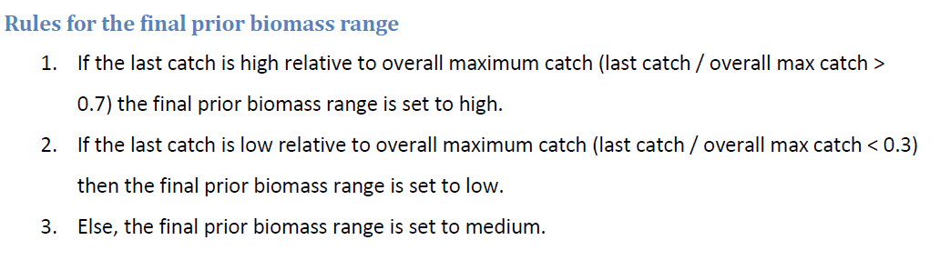

### BSM

???

## Intermediate Prior Biomass Range

### SPICT

No.

### CMSY

Can be manually defined with a biomass level and a year. If not then the default rules are:

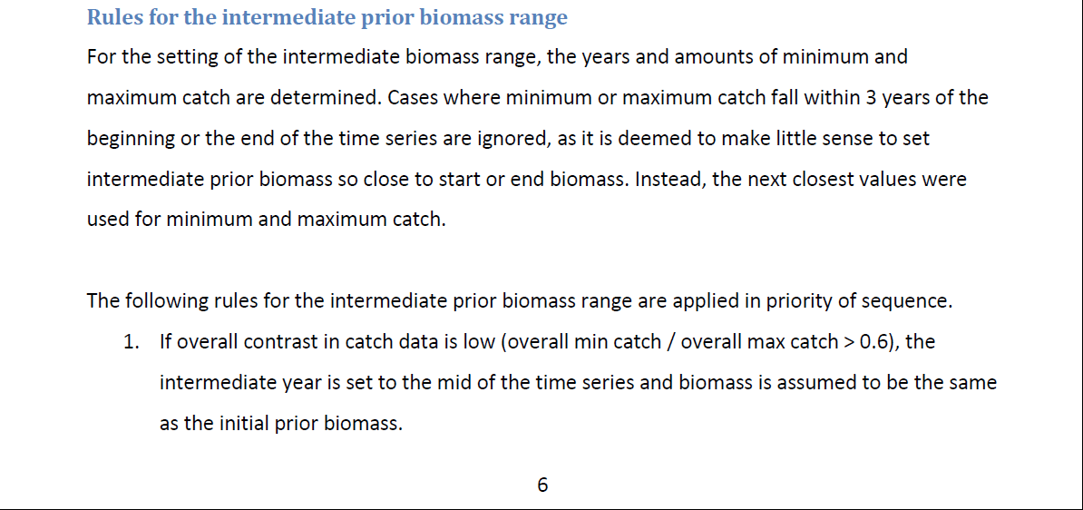

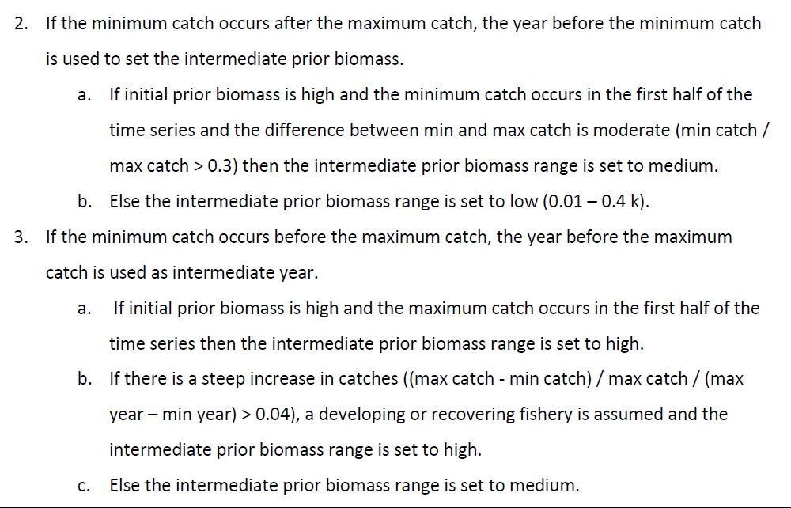

### BSM

???

## q

### SPICT

Can be set as a prior.

### BSM







## Alpha

SPICT sets as default a semi informative prior of 1.

## Beta

SPICT sets as default a semi informative prior of 1.

## Beta

SPICT by default sets a semi informative prior of 2. This can be turned off, or fixed.

## dataUncert (BSM)

set observation error as uncertainty in catch (default is SD=0.1)

## SigmaR (BSM)

Overall process error (default is SD=0.1)